Why going green is the new black when it comes to fashion

Do you care about global warming? Of course you do. But, even though you’re a stylish and fashionable person, can you justify buying fast fashion if you are concerned about the environment? Better to buy second-hand and vintage garments from your local St Vincent’s shop and you’ll be doing the Earth (and yourself) a favour.
“By buying vintage and second-hand from us, you’ll be able to put together a chic, unique look for yourself, while reducing both textile waste and over-production that are two of the biggest environmental footprints of the fashion trade.”
It’s often said that the garment industry is the second most polluting on Earth after fossil fuel energy. It is responsible for 10% of the carbon footprint of the world and it is well known that textile production consumes a vast amount of water, energy and chemicals.
Cotton making, for example, has a terrible impact on the environment from pesticides, toxic dyes and greenhouse gases during transportation.
And it isn’t only the planet that’s affected but also the people, because workers involved in this industry are often paid low wages, work extra-long hours and are sometimes threatened physically and mentally.
“What’s more, when shopping for pre-loved garments, you’re saving a perfectly wearable item from entering landfill where it would have been buried or burnt, releasing methane into the atmosphere and adding to global warming,”
According to a recent survey, UK consumers are switching to second-hand and vintage clothing in ever larger numbers as their interest in fast fashion fades. The poll conducted by waste management agency, BusinessWaste, found that 45% of those questioned said they would be happy to buy pre-owned clothes.
This reflects other studies that show that the second-hand clothing market is “set to double in the next five years.”
“If you let us help you assemble an environmentally-friendly and ethical wardrobe you’ll be able to put together a stylish and distinctive collection that fights global warming as well as saving you money… What’s more, we’re a charity and all St Vincent’s profits go to help people in need – so your fashion shopping will create a whole chain reaction of benefits!”
“And if you tire of any garment just donate it back to us and the environmental and social benefits will continue.”
- ends -
Issued by the St Vincent de Paul Society – registered charity number 1053992. For further information contact: >insert manager’s name and phone number< or call Kieran Knights at SVP National Office on 020 7703 303.
Did you know?

It takes 2,720 litres of water to make just one tee shirt. That's enough water for an average person to drink for nearly 2½ years!

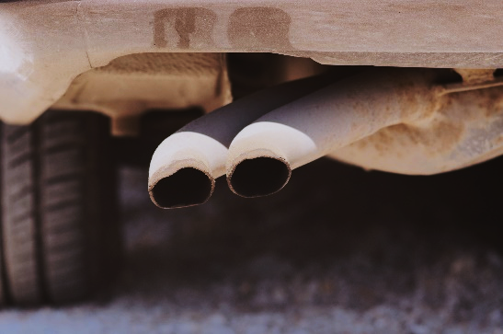
In Bangladesh, garment workers typically earn just £44 a month. That’s less than someone on the UK living wage would earn in a day!

Clothing consumption produces 1.4 tonnes of CO2 per household each year. That’s equivalent to the exhaust from 6,000 cars!
Each week the UK sends 11 million items of clothing into landfill. That’s almost one each for every man, woman and child living in Belgium, for example!

Every year St Vincent’s shops save 2.5 million kilos of clothes from landfill. That’s the same weight as 417 African bush elephants – the world’s heaviest land mammal!

Every year the St Vincent de Paul Society helps nearly 90,000 people in need. Much of that is thanks to those who buy from and donate to St Vincent’s shops.

-ends-

Issued by the St Vincent de Paul Society – registered charity number 1053992. For further information contact: >insert manager’s name and phone number< or call Kieran Knights at SVP National Office on 020 7703 303.

